Contact: Jackie Medina
(805) 889-1439
Jackie.medina@broadstreetpublishing.com

DISCOVER LIFE-CHANGING HABITS OF THINKING AND CONFIDENTLY LIVE GOD’S PURPOSE FOR YOUR MARRIAGE
Greg and Julie Gorman have written a classic in marriage books that brings a beautiful balance of timeless teachings from the world’s top thought leaders and combines them with interactive scenes from our favorite Bible heroes -Stephen Arterburn, Founder and Chairman of New Life Ministries; host of the #1 nationally syndicated Christian counseling talk sow New Life Live!

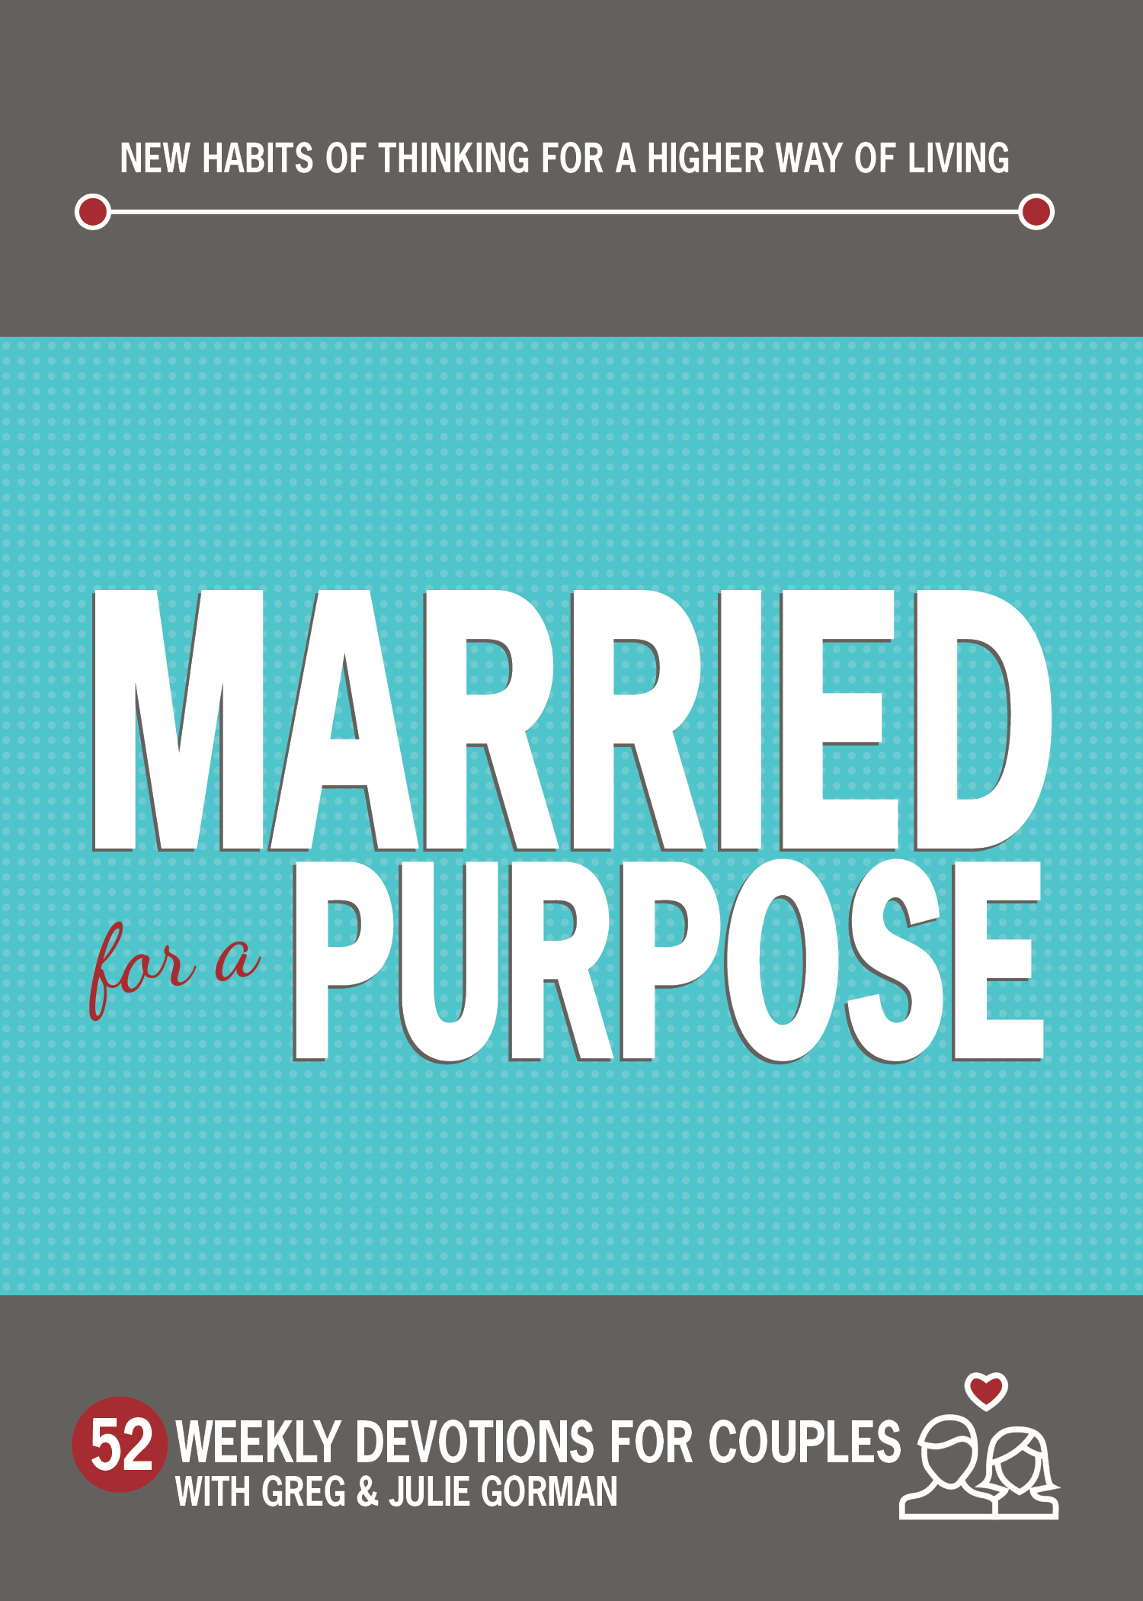
West Palm Beach, FL. Does the busyness of life crowd your time for quality connection? Want to cultivate transformation in a world filled with negativity? Do you aspire to live fully in God's purpose as a couple?

In Married for a Purpose (BroadStreet Publishing, January 2018) Greg and Julie Gorman share 52 power-packed devotions filled with encouragement, Scripture, prayers, and practical, next-step actions to help you live purpose focused, not problem focused, in your marriage. Each week you’ll uncover insights to create new habits of thought in your relationship, enriching your communication and unifying you physically, intellectually, emotionally, and spiritually.

Welcome God’s purpose for your marriage. Live the life God intended. He created you and your spouse to live Married for a Purpose.

Married for a Purpose helps couples discover:

- God’s specific purpose for their marriage (through insights and hands-on resources designed to help them celebrate and step forward united as one)
- A shift in mindset from “changing” their spouse to celebrating and dreaming together to fulfill God’s destiny for their marriage
- The benefits of working together and seizing opportunities to build one another up through daily encouragement and prayer while resisting the need to compare and compete
- A new way of living purpose-focused NOT problem-focused in their daily lives
- How to invite the limitless power of God to accomplish in their marriage what they could never accomplish alone
- Significance and fulfillment in marriage by living out God’s design for their marriage

Greg and Julie previously released an incredible resource for married couples Two are Better Than One: God Has a Purpose for Your Marriage (BroadStreet Publishing, June 2016). BroadStreet is pleased to now offer the new Married for a Purpose devotional as a companion to their first book! When read together, these two books present married couples of all ages with the perfect blueprint for a successful, loved-filled marriage.

About the Authors:

As entrepreneurs, certified life coaches, owners of small businesses, and parents of two teenagers and a now twenty-something-year-old, GREG and JULIE GORMAN understand busyness and the struggles in everyday life. When first married, they allowed problems to divide them. As God taught them the powerful truth that “problems divide; purpose unites,” they made a decision to pursue and seize a purpose-focused marriage and it changed everything. Greg and Julie make their home near West Palm Beach, Florida. You can learn more about their ministry at marriedforapurpose.com.

Two Are Better Than One is anchored in god’s Word and packed full of insights and hope for a stronger and better love in marriage. - Tim Clinton, EdD, author and President of the American Association of Christian Counselors

For additional information about BroadStreet Publishing, please visit www.broadstreetpublishing.com.
###

Married for a Purpose
Releasing January 1, 2018 Cover: Hardcover
ISBN: 978-1-4245-5632-8
Page Count: 160 Retail $14.99
Review copies, reprint permission and interviews are available.
Contact Jackie Medina, BroadStreet Publishing, 805-889-1439, jackie.medina@broadstreetpublishing.com

November 2017

